**EstateAgents Database Project**

***Firstly, I created the database ERD to ensure the correct amount of tables and data required would be present. This also helped me to visualise the relationships I would need to create between tables to query the data specific to the users requirements.***

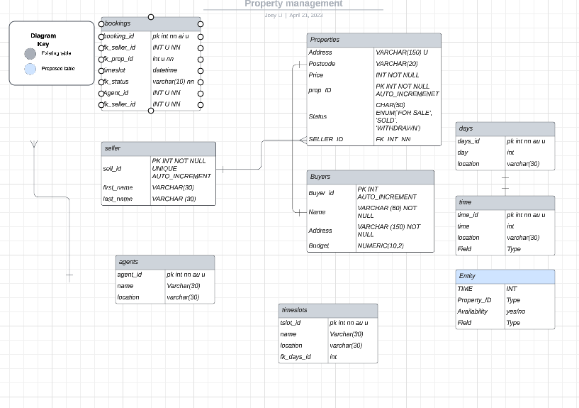

***Once the schema was created, I then went on to create my database and the tables within. I placed this all into one query and then copy and pasted them individually into another query dependent on the foreign keys the table required (bookings was last due to requiring the most foreign keys)***

USE EstateAgents;

CREATE TABLE seller (

sell_id INT UNIQUE PRIMARY KEY AUTO_INCREMENT,

first_name VARCHAR(20),

last_name Varchar(30)

);

CREATE TABLE buyer (

buyer_id INT UNIQUE PRIMARY KEY AUTO_INCREMENT,

name VARCHAR(60) NOT NULL,

budget NUMERIC(10,2)

);

CREATE TABLE agents (

agent_id INT UNIQUE PRIMARY KEY AUTO_INCREMENT,

name VARCHAR(60) NOT NULL,

location VARCHAR(30) NOT NULL

);

CREATE TABLE properties (

prop_id INT UNIQUE PRIMARY KEY AUTO_INCREMENT,

p_seller_id INT NOT NULL,

address VARCHAR(120) UNIQUE,

postcode VARCHAR(10),

price INT NOT NULL,

status ENUM('FOR SALE', 'SOLD', 'WITHDRAWN'),

CONSTRAINT fk_seller_id

FOREIGN KEY (fk_seller_id) REFERENCES seller(seller_id))

;

CREATE TABLE bookings (

book_id INT UNIQUE PRIMARY KEY AUTO_INCREMENT,

fk_seller_id INT IS NOT NULL,

fk_prop_id INT IS NOT NULL,

fk_buyer_id INT IS NOT NULL,

timeslot DATETIME,

fk_agent_id INT IS NOT NULL,

CONSTRAINT fk_seller_id

FOREIGN KEY (seller_id) REFERENCES seller(seller_id),

CONSTRAINT fk_prop_id

FOREIGN KEY (prop_id) REFERENCES properties(prop_id),

CONSTRAINT fk_buyer_id

FOREIGN KEY (buyer_id) REFERENCES buyer(buyer_id),

CONSTRAINT fk_agent_id

FOREIGN KEY (agent_id) REFERENCES agents(agent_id)

);

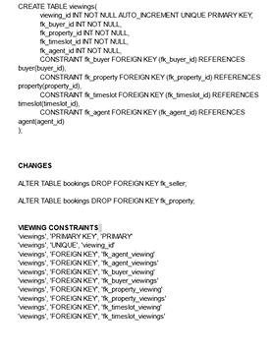

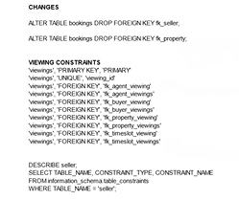

**CASE STUDY**

**Manage Property**

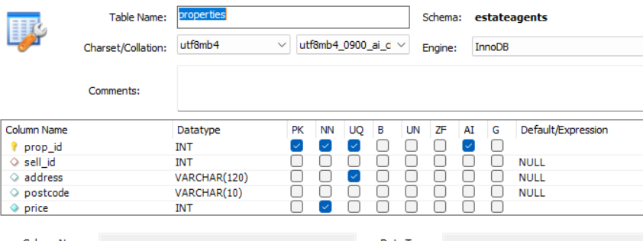

**1.A property can have the following status: FOR SALE, SOLD WITHDRAWN**



*I have used the enum datatype with specific values.*

**Add Property**

**2.**

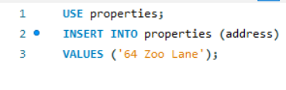



*I have given the property address a unique constraint to ensure no duplicates of property address*

***3.***

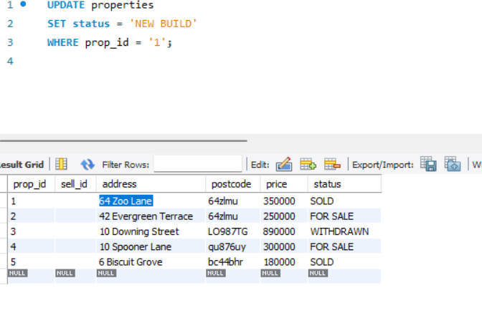

**

***PROCEDURE CODE FOR ADDING PROPERTIES, MAKING SURE THEY ARE CHECKED AND UPDATED ON THE PROPERTY TABLE.***

*USE estateagents;*

*DELIMITER //*

*CREATE PROCEDURE add_property(IN p_address VARCHAR(255), IN p_postcode VARCHAR(9), IN p_seller_id INT)*

*BEGIN*

*DECLARE address_exists INT;*

*SELECT COUNT(*) INTO address_exists*

*FROM properties*

*WHERE address = p_address AND postcode = p_postcode;*

*IF address_exists = 0 THEN*

*INSERT INTO properties (address, postcode, seller_id)*

*VALUES (p_address, p_postcode, p_seller_id);*

*ELSE*

*SIGNAL SQLSTATE '45000' SET MESSAGE_TEXT = 'The property with this address already exists.';*

*END IF;*

*END //*

*DELIMITER ;*

***PROCEDURE CODE FOR SEARCHING PROPERTIES BY POSTCODE AND MIN/MAX PRICE***

*USE estateagents;*

*DELIMITER //*

*CREATE PROCEDURE search_prop(*

*IN p_postcode VARCHAR(9),*

*IN p_price INT,*

*IN p_min_price INT,*

*IN p_max_price INT*

*)*

*BEGIN*

*DECLARE prop_search INT;*

*SELECT COUNT(*) INTO prop_search*

*FROM properties*

*WHERE postcode = p_postcode*

*AND price BETWEEN p_min_price AND p_max_price;*

*IF prop_search = 0 THEN*

*SIGNAL SQLSTATE '45000' SET MESSAGE_TEXT = 'There are no properties that fit your requirements';*

*ELSE*

*SELECT \**

*FROM properties*

*WHERE postcode = p_postcode*

*AND price BETWEEN p_min_price AND p_max_price;*

*END IF;*

*END //*

*DELIMITER ;*

***Procedure for withdrawing a property that is not sold***